**NMC SURVEILLANCE REPORT**

**APRIL 2023**



**NOTIFIABLE MEDICAL CONDITIONS SURVEILLANCE SYSTEM**

Issued by the National Institute for Communicable Diseases based

**Introduction**

This report summarizes data from the National Notifiable Medical Conditions Surveillance System (NMCSS) on cases diagnosed and reported in **April 2023**. Additionally, this report includes information on the distribution of case notifications by sources, such as clinical or laboratory notifications, merged cases (**see Appendix no. 3**), and the number of reported deaths. It monitors the use of the electronic NMC Reporting Application (App) for notification, data quality, specifically the completeness and timeliness of clinical diagnosis and notifications over time, and back-captured cases notified in March (**see Appendix nos. 1 and 3**). Category 4 NMCs and multi-system inflammatory syndrome (MIS-C) have been excluded from this report.

**Highlights**

* A total of 9 223 cases were reported in April 2023, with the majority of them being category 2 conditions.
* The NMC Reporting App was used to notify at least 98.2% (n= 5 881/5 985) of clinical notifications (range: 81-100%).
* In April 2023, the median time to report category 1 NMCs was one day (IQR: 0–2 days).
* The hospitalisation form was completed in at least 11% (n=36/326) of cases, whether admitted, discharged, or transferred out. This is lower than the previous month.

**NOTES:** For any additional informationcontact the NMC national technical team: [NMCAppSupport@nicd.ac.za](mailto:NMCAppSupport@nicd.ac.za) or NMC hotline 072 621 3805. Please refer to Appendices for NMC data flow, definitions and interpretation of epidemiology data in this report.

**DATA IS CONTINUOUSLY CLEANED, DE-DUPLICATED, AND UPDATED, HENCE IS SUBJECT TO CHANGE. ALL NUMBERS REPORTED ARE PRELIMINARY UNLESS OTHERWISE STATED. DATE OF DIAGNOSIS IS USED FOR REPORTING.**

# NMC data summary, April 2023

We report on 9 223 cases notified in April 2023, of these 8 594 cases were diagnosed and notified (current notifications) to the NMCSS in April 2023. In addition, there were 629 notifications diagnosed in the last two weeks of March 2023 and notified in April 2023 (referred to as delayed notifications) (see **Appendix no.3** for definitions). Overall, the majority were category 2 conditions (57.1%, n=5 268); of which 60.5 % (n= 3 363/5 268) were clinical notifications (**Table 1**). The provinces with the highest number of notifications were Gauteng (n= 2 680, 29.06 %), KwaZulu-Natal (n= 2 324, 25.2 %), and Western Cape (n=1 120, 12.1 %). Among the cases captured by clinicians, the majority were from Gauteng (36.9 %, n= 2 050) and KwaZulu-Natal (19.9 %, n=1 106). (**Figure 2**). The majority of the laboratory notifications were from KwaZulu-Natal (33.76 %, n=1 090 / 3 238). There were 1 043 back-captured clinical and merged notifications diagnosed from 22 February 2020 to 18 March 2023 and only notified in April 2023. (**See Appendix No. 1**).

**Table 1**: Description of NMC notifications by case source, April 2023.

|  |  |  |  |  |  |
| --- | --- | --- | --- | --- | --- |
|  | | **Case Source** | | | |
|  | **Total notifications**  **n (%)** | **Clinical notification only**  **n (%)** | | **Laboratory notification only**  **n (%)** | **Merged cases**  **(Clinical with laboratory results)**  **n (%)** |
| Category 1 | 3 805 (41.26) | 2 193 (11.8) | 1 363 (17.5) | | 249 (42.7) |
| Category 2 | 5 268 (57.12) | 3 363 (63.84) | 1 734 (32.92) | | 171 (3.25) |
| Category 3 | 150 (1.63) | 0 (0.0) | 141 (4.35) | | 9 (2.1) |
| **Grand Total** | **9 223 (100.00)** | **5 556  (60.2)** | **3 238 (35.13)** | | **429 (4.65)** |

*Data are continuously updated and are best available at the time of release.*

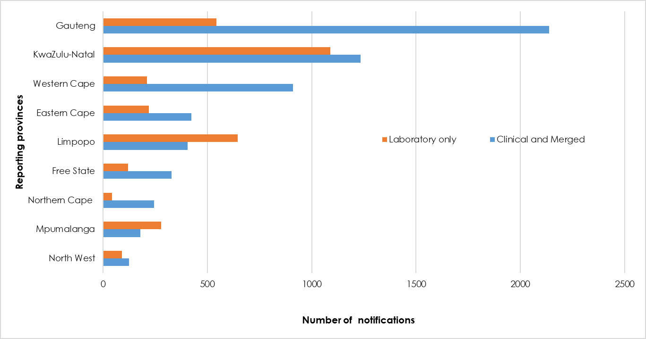

**Figure 2**: Distribution of notifications by province and notification type, April 2023

Of the clinical and merged notifications, 36.2 % (n= 2 173/ 5 985) were from the private sector (i.e. private hospitals, private practice, and the mining industry). We report an overall NMC Reporting App utilisation rate (proportion of clinical notifications reported using the App) of 98.2 % (n= 5 454 /5 556). In all provinces, the majority of the clinical notifications were captured using the NMC Reporting App (**Figure 3**) with utilisation ranging from 81.3% in North West to 100.0% in Free State.

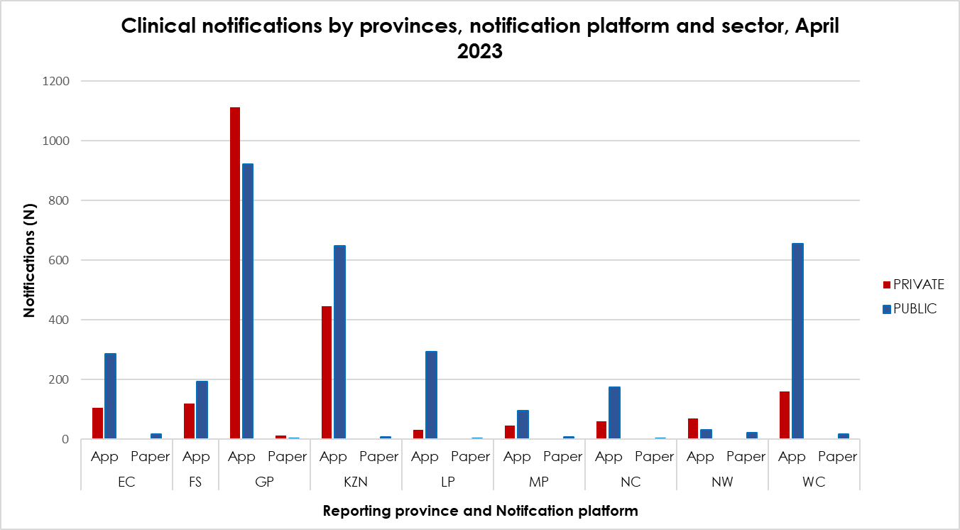

**Figure 3*:*** Clinical notifications notified by provinces, reporting platform, and sector, April 2023

The majority of the notified cases were male (54.0%, n=4 984). Individuals in the 35-39(10.0%, n=926) followed by under 5s (9.5%, n=873) age categories represented the majority of notified cases (**Table 2)**. Approximately 23.3% (n=1 470) of all notified cases were hospitalized, while 0.9% (n=84) were referred to another healthcare facility. There were 47 deaths notified during the reporting period.

**Table 2:** Age distribution by gender, admission status, and patient outcome, April 2023

|  |  |  |  |  |  |  |  |  |  |  |  |  |
| --- | --- | --- | --- | --- | --- | --- | --- | --- | --- | --- | --- | --- |
| **Age groups** | **Gender** | | | **Admission status** | | | | | **Patient Outcome** | | | |
|  | **Female** | **Male** | **Unknown** | **Discharged** | **Inpatient** | **Outpatient** | **Transferred** | **\*Unknown** | **Alive** | **Deceased** | **\*Unknown** | **Total (%)** |
| 0-4 | 398 | 475 | 0 | 48 | 238 | 193 | 12 | 382 | 478 | 8 | 387 | 873 (9.5) |
| 5-9 | 152 | 252 | 0 | 13 | 52 | 79 | 5 | 255 | 146 | 0 | 258 | 404 (4.4) |
| 10-14 | 163 | 392 | 0 | 9 | 38 | 76 | 6 | 426 | 125 | 1 | 429 | 555 (6.0) |
| 15-19 | 230 | 330 | 0 | 13 | 55 | 119 | 2 | 371 | 189 | 3 | 368 | 560 (6.1) |
| 20-24 | 263 | 250 | 0 | 10 | 71 | 158 | 8 | 266 | 245 | 0 | 268 | 513 (5.6) |
| 25-29 | 377 | 358 | 0 | 23 | 99 | 217 | 6 | 390 | 342 | 4 | 389 | 735 (8.0) |
| 30-34 | 451 | 475 | 0 | 32 | 167 | 281 | 11 | 435 | 484 | 7 | 435 | 926(10.0) |
| 35-39 | 402 | 467 | 0 | 23 | 144 | 279 | 8 | 415 | 450 | 2 | 417 | 869 (9.4) |
| 40-44 | 312 | 412 | 0 | 29 | 138 | 215 | 8 | 334 | 378 | 4 | 342 | 724 (7.8) |
| 45-49 | 282 | 322 | 0 | 18 | 128 | 176 | 2 | 280 | 323 | 2 | 279 | 604 (6.5) |
| 50-54 | 221 | 266 | 1 | 18 | 87 | 134 | 2 | 247 | 233 | 2 | 253 | 488(5.3) |
| 55-59 | 194 | 247 | 0 | 15 | 93 | 101 | 4 | 228 | 208 | 3 | 230 | 441 (4.8) |
| 60-64 | 167 | 175 | 0 | 16 | 59 | 78 | 2 | 187 | 154 | 3 | 185 | 342 (3.7) |
| 65+ | 434 | 365 | 0 | 12 | 82 | 99 | 5 | 601 | 194 | 4 | 601 | 799 (8.7) |
| Unknown | 192 | 198 | 0 | 9 | 19 | 24 | 3 | 335 | 47 | 4 | 339 | 390(4.2) |
| **Total**  **(%)** | **4 238**  **(46.0)** | **4 984 (54.0)** | **1**  **(0.0)** | **288**  **(3.1)** | **1 470 (15.9)** | **2 229**  **(24.2** | **84**  **(0.6)** | **5152**  **(55.9)** | **3 996 (43.3)** | **474**  **(0.5)** | **5158 (56.2)** | **9223** |

The Category 1 NMC notifications require completion of the hospitalisation form if the patient was admitted, transferred, or discharged at the time of notification. In April 2023, 326 patients diagnosed with category 1 conditions were either admitted, discharged, or transferred out. Of these, 11.0% (n=36/326) notifications had the hospitalisation form completed (**Figure 4).** Hospitalized cases of malaria and pertussis had better-completed hospital forms when compared to other category 1 NMCs.

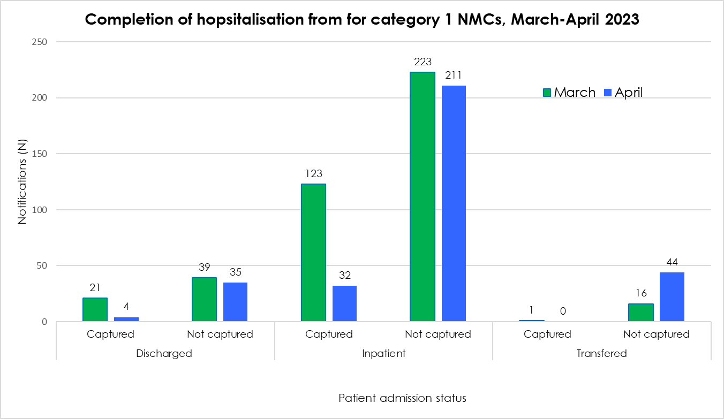

**Figure 4:** Completion of hospitalisation form for patients diagnosed with category 1 conditions who were either admitted, discharged, or transferred out, March- April 2023

**NMC Reporting App: Hospital form**

* Complete a hospitalization form for all category 1 hospitalized, discharged, and referred patients.
* When selecting the “Admission status” in the process of capturing a new case or editing an existing case, the “Hospitalization icon” will be activated.
* This form collects the risk factors of hospitalized patients.

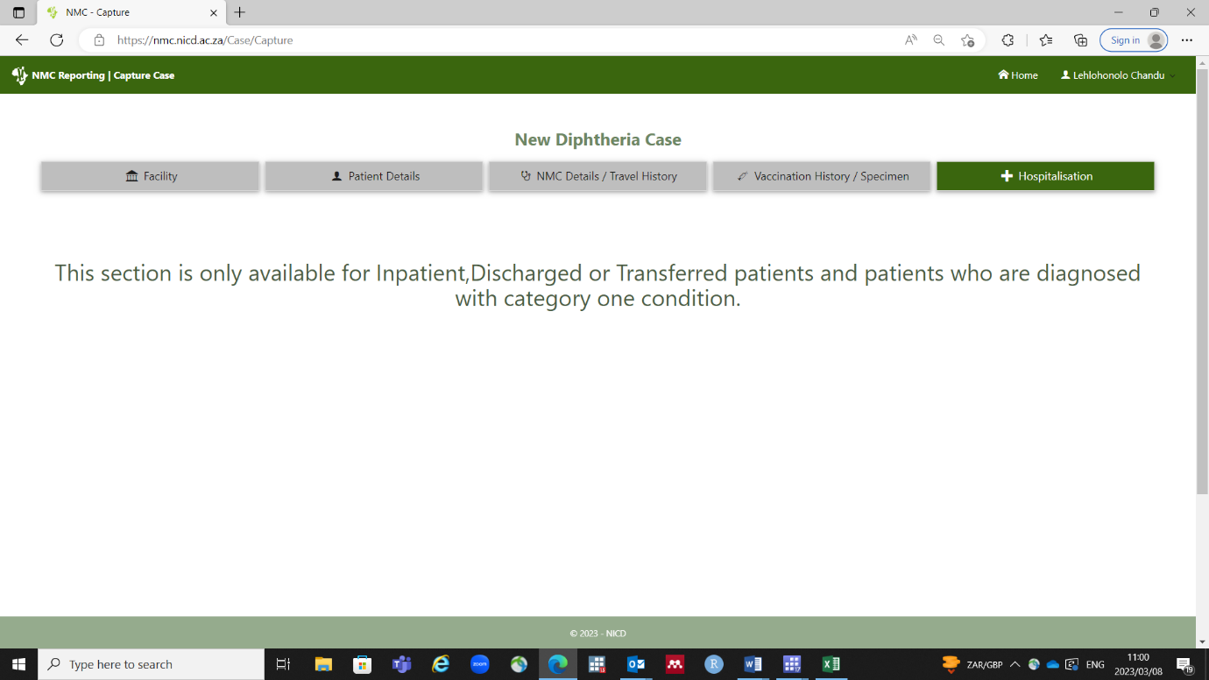

**Distribution of category 1 NMCs by province and number of deaths, April 2023**

COVID-19, which is now reported through the NMC surveillance system accounted for 65.7% (n=2 498) of category 1 notifications, followed by malaria (24.8%, n=92), pertussis (4.8%, n=182) and measles (2.9, n=112) (Table 3). In April, Gauteng (53.7%, n=1 342) and KwaZulu-Natal (21.5%, n=536) reported the majority of the COVID-19 notifications. Since March, there has been a reduction of 34% in the number of COVID-19 notifications. When compared to March 2023, the number of [malaria notifications](https://www.nicd.ac.za/malaria-cases-on-the-rise-10-may-2023/) increased by 86% in April. Although the onset of the malaria season in South Africa is between September and May and we anticipate higher case counts in the endemic provinces, the current increase in cases calls for alertness.

**Table 3**: Distribution of Category 1 NMC, April 2023

|  |  |  |  |  |  |  |  |  |  |  |  |  |  |
| --- | --- | --- | --- | --- | --- | --- | --- | --- | --- | --- | --- | --- | --- |
| **Category 1 NMC** | **Province** | | | | | | | | | **April 2023** | | **¥March 2023** | |
| **EC** | **FS** | **GP** | **KZN** | **LP** | **MP** | **NC** | **NW** | **WC** | **Total** | **2Total deaths n (4CFR)** | **Total** | **2Total deaths n (4CFR)** |
| Acute Flaccid Paralysis/Poliomyelitis | 1 | 1 | 2 | 1 | 0 | 0 | 0 | 1 | 1 | 7 | **0(0.0)** | 18 | **0(0.0)** |
| Acute rheumatic fever | 0 | 0 | 2 | 1 | 0 | 0 | 0 | 0 | 0 | 3 | **0(0.0)** | 1 | **0(0.0)** |
| Anthrax | 0 | 0 | 0 | 0 | 0 | 0 | 0 | 0 | 0 | **0** | **0(0.0)** | **0** | **0(0.0)** |
| Botulism | 0 | 0 | 0 | 0 | 0 | 0 | 0 | 0 | 0 | **0** | **0(0.0)** | **0** | **0(0.0)** |
| Cholera | 0 | 0 | 0 | 0 | 0 | 0 | 0 | 0 | 0 | **0** | **0(0.0)** | 5 | **0(0.0)** |
| Congenital Rubella Syndrome | 0 | 0 | 0 | 0 | 0 | 0 | 0 | 0 | 0 | **0** | **0(0.0)** | 7 | 2(28.6) |
| Diphtheria | 1 | 0 | 0 | 0 | 0 | 0 | 0 | 0 | 2 | 3 | 1 (33.3) | 1 | **0(0.0))** |
| Enteric fever (typhoid or paratyphoid fever) | 2 | 0 | 8 | 1 | 0 | 1 | 0 | 1 | 4 | 17 | **0(0.0)** | 24 | **2(8.3)** |
| Foodborne illness outbreak | 0 | 3 | 2 | 3 | 0 | 0 | 0 | 0 | 1 | 9 | 1 (11.1) | 8 | **0(0.0)** |
| Haemolytic uraemic syndrome (HUS) | 0 | 0 | 0 | 0 | 0 | 0 | 0 | 0 | 1 | 1 | **0(0.0)** | **0** | **0(0.0)** |
| Listeriosis | 0 | 0 | 1 | 0 | 0 | 0 | 0 | 0 | 2 | 3 | **0(0.0)** | 8 | 1(12.5) |
| $Malaria | 8 | 22 | 117 | 97 | 535 | 112 | 5 | 27 | 19 | 942 | 4 (0.4) | 504 | 6 (1.2) |
| Measles | 0 | 0 | 22 | 14 | 56 | 4 | 2 | 3 | 11 | 112 | **0(0.0)** | 409 | **1(0.2)** |
| Meningococcal Disease | 1 | 0 | 1 | 2 | 1 | 0 | 0 | 0 | 4 | 9 | 1 (11.1) | 11 | **1(9.1)** |
| Monkeypox | 0 | 0 | 1 | 0 | 0 | 0 | 0 | 0 | 0 | 1 | **0(0.0)** | **0** | **0(0.0)** |
| Pertussis | 18 | 32 | 55 | 28 | 12 | 12 | 0 | 4 | 21 | 182 | **0(0.0)** | 211 | **0(0.0)** |
| Plague | 0 | 0 | 0 | 0 | 0 | 0 | 0 | 0 | 0 | **0** | **0(0.0)** | **0** | **0(0.0)** |
| Rabies (human) | 0 | 0 | 0 | 3 | 0 | 0 | 0 | 0 | 0 | 3 | **0(0.0)** | 4 | **0(0.0)** |
| Respiratory disease caused by a novel respiratory pathogen | 0 | 0 | 0 | 0 | 0 | 0 | 0 | 0 | 0 | **0** | **0(0.0)** | **0** | **0(0.0)** |
| COVID-19 | 113 | 126 | 1342 | 536 | 8 | 92 | 95 | 45 | 141 | 2498 | **0(0.0)** | **3 827** | **0(0.0)** |
| Rift Valley Fever (human) | 0 | 0 | 0 | 0 | 0 | 0 | 0 | 0 | 0 | **0** | **0(0.0)** | **0** | **0(0.0)** |
| Rubella | 1 | 2 | 6 | 2 | 2 | 1 | 0 | 0 | 1 | 15 | **0(0.0)** | 20 | **0(0.0)** |
| Smallpox | 0 | 0 | 0 | 0 | 0 | 0 | 0 | 0 | 0 | **0** | **0(0.0)** | **0** | **0(0.0)** |
| **Viral haemorrhagic fever diseases | 0 | 0 | 0 | 0 | 0 | 0 | 0 | 0 | 0 | **0** | **0(0.0)** | **0** | **0(0.0)** |
| Waterborne illness outbreak - UNDEFINED | 0 | 0 | 0 | 0 | 0 | 0 | 0 | 0 | 0 | **0** | **0(0.0)** | 1 | **0(0.0)** |
| Yellow fever | 0 | 0 | 0 | 0 | 0 | 0 | 0 | 0 | 0 | **0** | **0(0.0)** | **0** | **0(0.0)** |
| **Total** | **145 (3.8)** | **186**  **4.9)** | **1559**  **(41.0)** | **688 (18.1)** | **614 (16.1)** | **222**  **(5.8)** | **102**  **(2.7)** | **81**  **(2.1)** | **208**  **(5.5)** | **3 805** | **7**  **(0.2)** | **1 232** | **13**  **(1.1)** |

EC (Eastern Cape). FS (Free State). GP (Gauteng). KZN (KwaZulu-Natal). LP (Limpopo). MP (Mpumalanga). NW (North West). NC (Northern Cape). WC (Western Cape). **Viral Haemorrhagic fever diseases: Ebola or Marburg viruses, Lassa virus, Lujo virus, novel or new world arenaviruses. Crimean-Congo haemorrhagic fever. ¥* March 2023 data for comparison purposes (notification date. $These data do not include malaria cases reported to DHIS2. Efforts are underway to harmonize reporting of malaria cases through the different systems. ***Data are updated continually and are best available at the time of release.***

***_______________________________________***

2 Patient’s vital status at the time of reporting. This is not always the final clinical outcome. The system depends on clinicians to update the vital status of patients. ,4 CFR- Case Fatality Rate (%) = (No. of deaths/ No. of cases) x 100

**Distribution of category 2 NMCs by province and number of deaths, April 2023**

In April 2023, a total of 5 268 NMC category 2 notifications were reported. Pulmonary tuberculosis infection (46.2%) accounted for the majority of category 2 NMC notifications, followed by hepatitis B (15.8%) and bilharzia (15.1%). There have been 17 deaths attributed to tuberculosis infection.

**Table 4:** Distribution of Category 2 NMC, April 2023

|  |  |  |  |  |  |  |  |  |  |  |  |  |  |
| --- | --- | --- | --- | --- | --- | --- | --- | --- | --- | --- | --- | --- | --- |
| **Category 2 NMC** | **Provinces** | | | | | | | | | **April 2023** | | **¥*March 2023** | |
| **EC** | **FS** | **GP** | **KZN** | **LP** | **MP** | **NC** | **NW** | **WC** | **Total** | **2Total deaths**  **n(4CRF)** | **Total** | **2Total deaths**  **n(4CRF)** |
| Agricultural or stock remedy poisoning | 3 | 10 | 50 | 0 | 1 | 1 | 3 | 0 | 7 | 75 | 11 (14.7) | 66 | 4 (6,1) |
| Bilharzia (schistosomiasis) | 57 | 0 | 26 | 344 | 216 | 135 | 0 | 2 | 16 | 796 | **0 (0.0)** | 944 | **0(0.0)** |
| Brucellosis | 0 | 0 | 0 | 0 | 0 | 0 | 0 | 1 | 0 | 1 | **0(0.0)** | **0** | **0(0.0)** |
| Congenital syphilis | 10 | 1 | 10 | 38 | 1 | 0 | 3 | 0 | 13 | 76 | 4 (5.3) | 90 | **0(0.0)** |
| Haemophilus influenzae type B | 0 | 0 | 4 | 0 | 0 | 1 | 0 | 0 | 0 | 5 | 2(40.0) | 4 | **0(0.0)** |
| 3Hepatitis A | 25 | 16 | 62 | 59 | 22 | 20 | 16 | 15 | 119 | 354 | 1 (0.3) | 410 | **0(0.0)** |
| Hepatitis B | 71 | 49 | 51 | 601 | 0 | 11 | 3 | 36 | 11 | 833 | 1 (0.1) | 1045 | 1(0,1) |
| 3Hepatitis C | 2 | 3 | 5 | 0 | 0 | 1 | 0 | 0 | 0 | 11 | **0(0.0)** | 3 | **0(0.0)** |
| Hepatitis E | 0 | 1 | 0 | 0 | 0 | 0 | 0 | 0 | 1 | 2 | **0(0.0)** | 8 | **0(0.0)** |
| Lead poisoning | 0 | 0 | 0 | 0 | 0 | 0 | 0 | 0 | 0 | **0** | **0(0.0)** | **0** | **0(0.0)** |
| Legionellosis | 0 | 0 | 0 | 0 | 0 | 0 | 0 | 0 | 4 | 4 | **0(0.0)** | 3 | **0(0.0)** |
| Leprosy | 0 | 0 | 0 | 0 | 0 | 0 | 0 | 0 | 0 | **0** | **0(0.0)** | **0** | **0(0.0)** |
| 5Maternal death (pregnancy. childbirth and puerperium)3 | 0 | 0 | 0 | 0 | 0 | 0 | 0 | 0 | 0 | **0** | **0(0.0)** | 3 | 3(n/a) |
| Mercury poisoning | 0 | 0 | 0 | 0 | 0 | 0 | 0 | 0 | 0 | **0** | **0(0.0)** | **0** | **0(0.0)** |
| Soil-transmitted helminths | 0 | 0 | 1 | 0 | 0 | 0 | 0 | 0 | 1 | 2 | **0(0.0)** | 1 | **0(0.0)** |
| Tetanus | 0 | 0 | 1 | 1 | 0 | 0 | 0 | 0 | 0 | 2 | **0(0.0)** | 1 | **0(0.0)** |
| 5Tuberculosis: extensively drug-resistant (XDR -TB) | 1 | 1 | 2 | 0 | 1 | 0 | 0 | 0 | 0 | 5 | **0(0.0)** | 8 | **0(0.0)** |
| 5Tuberculosis: multidrug- resistant (MDR -TB) | 5 | 2 | 18 | 23 | 4 | 0 | 2 | 1 | 24 | 79 | **0(0.0)** | 80 | 1 (1,3) |
| 5Tuberculosis: extra-pulmonary | 51 | 45 | 233 | 78 | 17 | 7 | 29 | 14 | 116 | 590 | 4 (0.7 | 838 | 11 (1,3) |
| 5Tuberculosis: pulmonary | 249 | 129 | 631 | 480 | 171 | 60 | 129 | 64 | 520 | 2433 | 17 (0.7) | 3266 | 31 (0,9) |
| **Total**  **(%)** | **474 (9.0)** | **257 (4.9)** | **1094 (20.8)** | **1624 (30.8)** | **433 (8.2)** | **236 (4.5)** | **185 (3.5)** | **133 (2.5)** | **832**  **(15.8)** | ***5268*** | ***40***  ***(0.8)*** | **6 770** | **51**  **(0.8)** |

EC (Eastern Cape). FS (Free State). GP (Gauteng). KZN (KwaZulu-Natal). LP (Limpopo). MP (Mpumalanga). NW (North West). NC (Northern Cape). WC (Western Cape). ¥*March 2023 data for comparison purposes. ***Data are updated continually and are best available at the time of release.***

**_______________________________________________**

5 Parallel systems exist for reporting under the administration of the National Department of Health., 2Patient’s vital status at the time of reporting. This is not always the final clinical outcome. The system is dependent on clinicians to update the vital status of patients, should it change over time,4 CRF- Case Fatality Rate (%) = No. of deaths/ No. of cases x 100

**The average active users on the NMC App, December 2020 to April 2023**

In April 2023, there were 303 average active users (sum of total access per day/number of days where users were active) (**Figure 5**). A total of 839 newly authorised users were recorded in April.

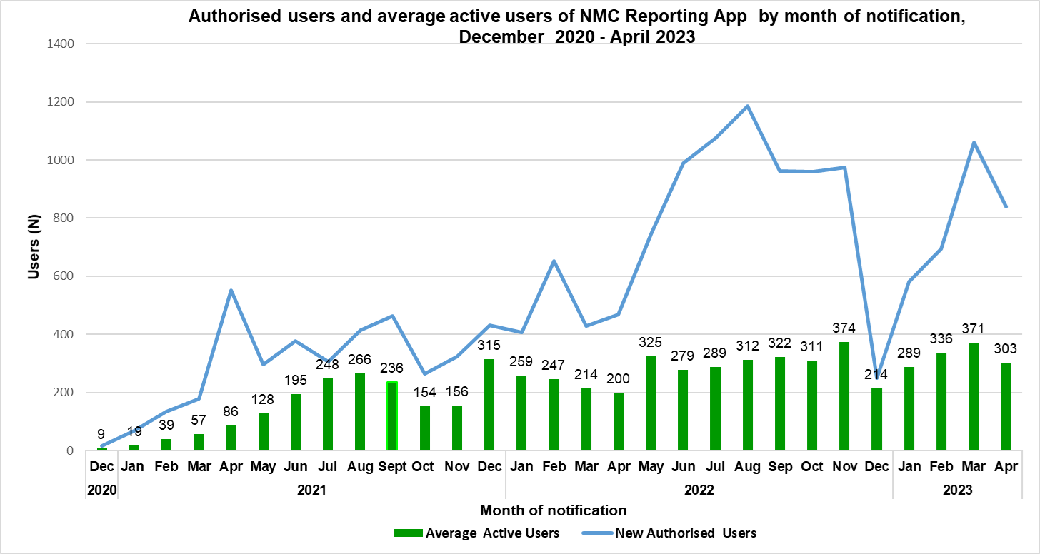

**Figure 5:** The average active user of the improved NMC reporting Application, December 2020-April 2023.

**Completeness of clinical notifications in the NMCSS, April 2023**

Completeness refers to the proportion of complete data entries per variable in the dataset among clinical and merged notifications. In April 2023, patient name, and surname were 100% complete on both App and paper platforms (**Table 5**). The patient folder/file number is poorly completed on both platforms. The symptom’s onset date and patient outcome status are poorly completed in the App as compared to the paper.

**Table 5:** NMCSS data completeness on both reporting platforms, April 2023

|  |  |  |
| --- | --- | --- |
| **Variables** | **NMC App (n=5 881)** | **Paper-based (n= 104)** |
| **Complete n (%)** | **Complete n (%)** |
| Patient folder no. | 4 326 (73.6) | 67 (64.4) |
| Patient first name | 5 881 (100.0) | 104 (100.0) |
| Patient surname | 5 881 (100.0) | 104(100.0) |
| Date of birth | 5 819 (98.9) | 104 (100.0) |
| Symptom Onset Date | 4 115 (70.0) | 99 (95.2) |
| Diagnosis Date | 5 879 (100.0) | 104 (100.0) |
| Patient outcome status | 3 966 (67.4) | 99 (95.2) |

**Timeliness of clinical notifications by NMC categories and province, April 2023**

Timeliness is measured by the number of days from the time of diagnosis of the NMC to the time of notification. Overall, it took a median of a day (IQR:0-2) to report category 1 NMCs in April 2023 (**Table 7**). The interval between the beginning of NMC symptoms and the diagnosis was calculated. Category 1 NMCs were diagnosed after a median of 2 days (IQR:0-4) of symptoms onset in 709 notifications.

**Table 7:** Time to notification of Category 1 and 2 NMC, April 2023

|  |  |  |  |  |  |
| --- | --- | --- | --- | --- | --- |
| **Category 1** | **Months** | **All cases notified in 2023** | | **All cases notified in 2022** | |
|  | **N¥** | **Median (IQR*)** | **N¥** | **Median (IQR*)** |
| **December** |  |  | **511** | **1 (0-2)** |
| November |  |  | **576** | 0(0-1) |
| October |  |  | **606** | 0(0-2) |
| September |  |  | **464** | 1(0-2) |
| August |  |  | **276** | 1(0-6) |
| July |  |  | **220** | 1(0-2) |
| June |  |  | **201** | 1(0-3) |
| May |  |  | **23** | 1(0-4) |
| April | **π2460** | 1(0-2) | **24** | 2 (0-6) |
| March | **772** | 0 (0-2) | **24** | 1(0-4) |
| February | **754** | 0 (0-2) | **80** | 1(0-3) |
| January | **746** | 1 (0-2) | **41** | 1(0-5) |
| **Category 2** | **December** |  |  | **¥2 566** | **2 (0-7)** |
| November |  |  | **¥5 283** | 2(0-7) |
| October |  |  | **¥5 111** | 2(0-6) |
| September |  |  | **¥4 493** | 2(0-6) |
| August |  |  | **¥4 249** | 2(0-7) |
| July |  |  | **¥3 286** | 2(0-7) |
| June |  |  | **¥2 658** | 2 (0-6) |
| May |  |  | **127** | 10(3-34) |
| April | **3 533** | 2(0-6) | **112** | 9 (3-21) |
| March | **6 020** | 4 (0-22) | **168** | 8(2-30) |
| February | **5 233** | 4 (0-15) | **262** | 8(2-26) |
| January | **3 669** | 2 (0-7) | **271** | 11(3-52) |

IQR: Interquartile range is based on 25 and 75 quartiles, ¥The increase is due to Tuberculosis notifications and NMC App uptake by the TB program to notify TB. π The increase is due to the inclusion of COVID-19 notifications

**Conclusion**

The NMC Reporting App was used to report a greater number of clinical notifications from the Gauteng and KwaZulu-Natal provinces. This corresponds to the increased uptake of the App in provinces. The increase in average active users over time is an indication of the provinces' acceptance of the NMC Reporting App. Hospital form data is poorly completed. The majority of back-captured tuberculosis cases resulted from a delay in reporting cases.

**Recommendations**

* We recommend "whitelisting" the NMC Reporting App on the provincial departmental intranet to make the electronic notification platform more accessible to health facilities.
* For all category 1 NMCs, including COVID-19, we recommend that hospital forms be completed for all hospitalized patients.
* To reduce the burden of data capture on the App, we recommend submitting pre-existing databases for ingestion into the NMCSS.

# Appendix 1: Back-captured clinical notifications

**Table 8:** NMC conditions diagnosed (22 February 2020 to 18 March 2023) and notified in April 2023

|  |  |  |  |  |  |  |  |  |  |  |
| --- | --- | --- | --- | --- | --- | --- | --- | --- | --- | --- |
| **NMC Condition** | **EC** | **FS** | **GP** | **KZN** | **LP** | **MP** | **NC** | **NW** | **WC** | **Total n (%)** |
| Bilharzia (schistosomiasis) | 0 | 0 | 0 | 0 | 0 | 2 | 0 | 0 | 0 | 2 (0.2) |
| Congenital syphilis | 3 | 0 | 0 | 0 | 0 | 0 | 1 | 0 | 3 | 7 (0.7) |
| COVID-19 | 1 | 0 | 16 | 2 | 0 | 0 | 0 | 6 | 16 | 41 (3.9 |
| Enteric fever (typhoid or paratyphoid fever) | 0 | 0 | 0 | 0 | 0 | 0 | 0 | 0 | 1 | 1 (0.1) |
| Haemophilus influenzae type B | 0 | 0 | 1 | 0 | 0 | 0 | 0 | 0 | 0 | 1 (0.1) |
| Hepatitis A | 1 | 0 | 0 | 0 | 0 | 0 | 0 | 0 | 2 | 3 (0.3) |
| Hepatitis B | 6 | 2 | 18 | 5 | 0 | 6 | 1 | 0 | 1 | 39 (3.7) |
| Hepatitis C | 0 | 0 | 2 | 1 | 0 | 1 | 0 | 0 | 0 | 4 (0.4) |
| Legionellosis | 0 | 0 | 1 | 0 | 0 | 0 | 0 | 0 | 0 | 1 (0.1) |
| Malaria | 0 | 1 | 1 | 1 | 0 | 0 | 0 | 0 | 4 | 7 (0.7) |
| Maternal death (pregnancy, childbirth, and puerperium) | 0 | 0 | 1 | 0 | 0 | 0 | 0 | 0 | 0 | 1 (0.1) |
| Tuberculosis: multidrug- resistant (MDR -TB) | 1 | 0 | 4 | 24 | 0 | 0 | 0 | 0 | 2 | 31 (3.0) |
| Tuberculosis: extra-pulmonary | 3 | 0 | 281 | 11 | 8 | 1 | 1 | 4 | 10 | 319 (30.6 |
| Tuberculosis: pulmonary | 22 | 21 | 312 | 136 | 14 | 2 | 24 | 10 | 44 | 585 (56.1) |
| Waterborne illness outbreak - UNDEFINED | 0 | 0 | 1 | 0 | 0 | 0 | 0 | 0 | 0 | 1 (0.1) |
| **Total (%)** | **37**  **(3.3)** | **24**  **(2.3)** | **638 (61.22.8)** | **180**  **(17.3)** | **22**  **(2.1)** | **12**  **(1.2)** | **27(**  **2.6)** | **20**  **(1.9)** | **83**  **(8.0)** | **1 043** |

**Table 9:** Back capture: Time to notification of category 1 and 2 NMC, April 2023

|  |  |  |  |  |
| --- | --- | --- | --- | --- |
|  | Months | Back notified cases in April 2023 | |  |
|  |  | **N¥** | **Median (IQR*)** | **Min- Max** |
| Category 1 | April | 50 | 130 (48-342) | 23-667 |
| March | 16 | 61(40-150) | 18-396 |
| February | 13 | 36(24-53) | 18-86 |
| January | 10 | 205(30-370) | 19-370 |
| Category 2 | April | 993 | 224 (55-672) | 16 -1155 |
| March | 1 338 | 156(56-331) | 15-1467 |
| February | 847 | 77(42-145) | 19-1699 |
| January | 616 | 62(40-126) | 18-771 |

*IQR: Interquartile range is based on 25 and 75 quartiles; πExcluding Leprosy cases

# Appendix 2: Summary of NMCSS Data Flow

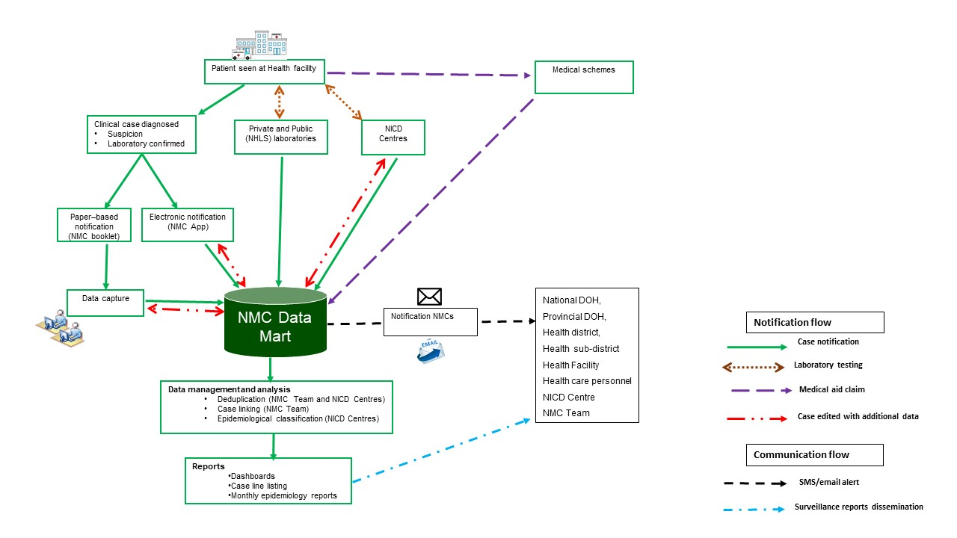

**Figure 7:** Summary of data flow within the NMC surveillance system

# Appendix 3: NMC Categories, and Case Classification Definitions

**NMC categories**

**Category 1:** NMCs are notifiedby the most rapid means available upon diagnosis, followed by a written or electronic notification to the Department of Health **within 24 hours** of diagnosis by healthcare providers, private health laboratories or public health laboratories. These conditions must be notified based on clinical suspicion irrespective of laboratory confirmation.

**Category 2:** NMCsnotified through a written or electronic notification to the Department of Health of clinical or laboratory diagnosis **within 7 days** by healthcare providers, private health laboratories or public health laboratories.

**Category 3:** NMCs are notified through a written or electronic notification to the Department of Health **within 7 days** of diagnosis by public and private health laboratories.

**Category 4:** NMCs are notified through a written or electronic notification to the Department of Health **within 1 month** of diagnosis by public and private health laboratories.

**Case Classification definitions**

**Clinical cases:** are cases reported to the NMC by health care providers at facilities, either through the completion of a paper form that is faxed, emailed to the National Institute of Communicable Diseases (NICD), or by direct data entry into the NMC application on a PC, laptop or mobile device. The diagnosis is made by the clinician on the basis of case definitions published on the NICD website.

**Laboratory cases:** are cases that are downloaded into the NMC database directly from the National Health Laboratory Services (NHLS) laboratory information system. The NMC application applies the case definitions that are published on the NICD website. Private sector data is being sourced.

**Merged cases:** are cases where a case was notified by a health care provider at the facility (a ‘clinical case’) AND the laboratory issued a report with a positive result for the same case (a ‘laboratory case). The NMC App is set up to automatically detect and link clinical and laboratory case notifications. The NICD specialist Centres and NMC data team review all cases and manually link any remaining clinical and laboratory cases

**Notification capture times**

**Current notification**: All cases diagnosed and notified in the current month

**Delayed notification:** All cases diagnosed in the last 14 days from the previous month

**Back capture notification**: All cases diagnosed in previous months and before the last 14 days of the previous month